12/7/2025
PREDICTING MONTHLY ELECTRICITY CONSUMPTION

A project report submitted for CPSC 610-2 Python for Data Analysis
Master of Data Analytics program

Contents
1. Executive Summary: 3
2. Introduction: 3
3. Data Set Overview 4
3.1 Properties.csv 4
3.2 Meters.csv 4
3.3 Meter_entries.csv 4
3.4 Uses.csv 4
4. Data Cleaning: 5
4.1 Filtering Relevant Meter Readings: 5
4.2 Merging Datasets 5
4.3 Handling Missing Values 6
4.4 Outliers (Gross Floor Area) Removal. 6
4.5 Target Transformation 6
5. Exploratory Data Analysis (EDA) 7
5.1 Summary Statistics 7
5.2 Distribution of Electricity Usage 7
5.3 Relationship Between the Size of Buildings and Usage 8
5.4 Energy Consumption by type of property 9
5.5 Correlation Analysis 10
6. Feature Engineering: 11
6.1 Temporal Features 11
6.2 Use Allocation Features 11
6.3 Encoded Categorical Variables 11
6.4 Outlier and Log Transform 11
7. Model Development 12
7.1 Linear regression: 12
7.2 Random Forest Regressor 12
7.3 Train and test split 12
8. Model Evaluation: 12
8.1 Linear Regression Results 13
8.2 Random Forest Result: 13
8.3 Actual V/s Predicted: Random Forest 14
9. Interpretation and insight: 15
10. Conclusion: 16

Executive Summary:
The proposed project estimates the consumption of building electricity through the multi-dataset integration method (properties, meters, uses, and meter entries). Two models were created after thorough data cleaning, transformation, and feature engineering Linear Regression and Random Forest. Random Forest model was significantly better and had a high R2 besides lowering the error measures.
The observed important variables that forced the use of electricity were gross floor area, total use area and property type. Seasonal factors and occupancy factors had little impact.
The results provide practical suggestions to the energy management team, municipalities, and facility planners to focus on large high-consumption buildings as the subject of conservation and benchmarking.

Introduction:
Electricity forecasting is important in energy planning, cost control, sustainability, and operation in buildings. This project is based on estimating the monthly electricity consumption based on actual building data employed in ENERGY STAR Portfolio Manager system.
Four datasets were availed, which explained property features, meter information, monthly readings, and floor area applications. These data sets were processed, combined, evaluated and they were applied to produce machine learning models which could predict monthly power consumption.
This project had the following objectives:
- To purify and combine various real-world data.
- To conduct an exploration data analysis (EDA) to get a picture of building energy behavior.
- To design predictive power enhancing features that matter.
- To train and test at least two machine learning models. To make sense of results and extract action.
This report narrates the whole analysis process, starting with the data preparation, up to the interpretation of the model.

Data Set Overview
Four CSV files were provided:

3.1 Properties.csv
id-level: Building-level characteristics:
- Property Type - Self-Selected
- Gross Floor Area
- Occupancy (%)
- Address and metadata
- Portfolio Manager ID

3.2 Meters.csv
Meter-level metadata:
- Portfolio Manager Meter ID
- Meter Type (Electric grid, Gas, Steam, etc.)
- Units

3.3 Meter_entries.csv
Records of consumption per month:
- Start Date, End Date
- Usage/Quantity
- Usage Units
- Portfolio Manager ID
- Meter Type

3.4 Uses.csv
Disaggregation of building floor area by the use type:
- Gross Floor Area for Use
- Use Type
- Portfolio Manager ID
All areas were understood by referring to the Data Dictionary, which is given in the project appendix.

Data Cleaning:
One of the most significant stages was data cleaning. The steps that were carried out were as follows:

4.1 Filtering Relevant Meter Readings:
The filtering of relevant meter readings is to clean up the unwanted entries in the database.

We retained only:
- Meter Type = Electric - Grid
- Usage Units = kWh

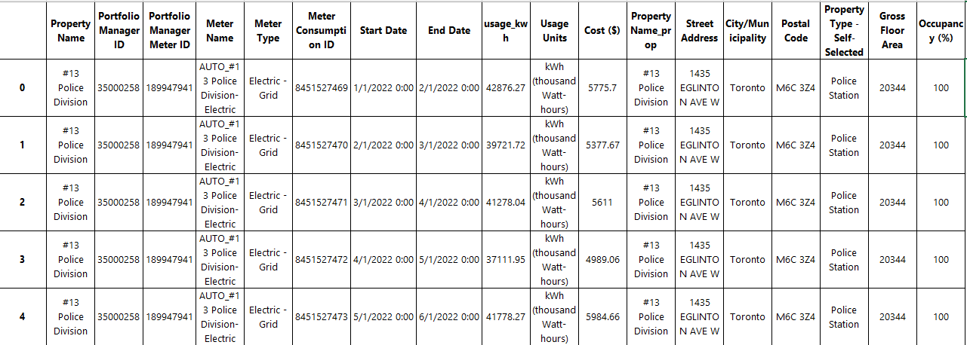
This guarantees some consistency in measurement of the object of prediction.

4.2 Merging Datasets

Several mergers were carried out with the use of Portfolio ManagerID:
meterentries.csv
- n_uses (number of types of unique use)
- total used area (the sum of the floor area uses)
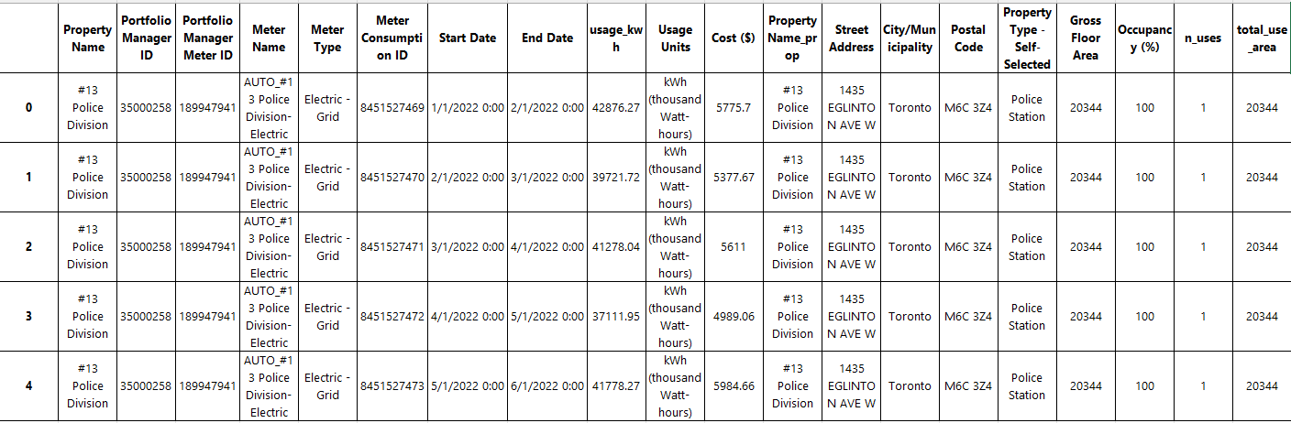
(Preliminary display of the initial 5 rows of the outcome of the merging data before cleaning this outcome.)

4.3 Handling Missing Values

- Numerical missing data - substituted with median.
- Missing values that are categorical - substituted with Unknown.
- Missing rows when usage_kwh was missing
This makes modeling not to break under null values.

4.4 Outliers (Gross Floor Area) Removal.

Sizes of buildings were extremely diverse. Extreme outliers above 99 th percentile were eliminated: 302,735 sq ft

4.5 Target Transformation

There was a very skewed electricity consumption (e.g. 10 million kWh and higher).
To normalize:

log_usagekwh = log1p(usage_kwh)

Exploratory Data Analysis (EDA)

5.1 Summary Statistics
We produced descriptive statistics of:
- usage_kwh
- Gross Floor Area
- Occupancy (%)
- totalusearea
- month, year

Distribution of Electricity Usage
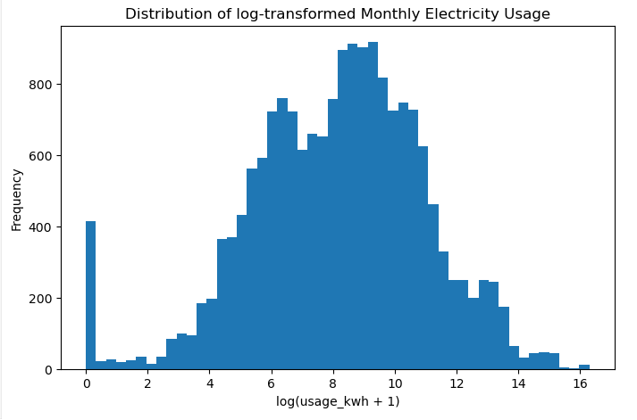

A logarithmic histogram (histogram of log_usagekwh) showed a more normal distribution than did raw values.

5.3 Relationship Between the Size of Buildings and Usage

A scatter plot was drawn to compare:
- x-axis = Gross Floor Area
- y-axis = usage_kwh
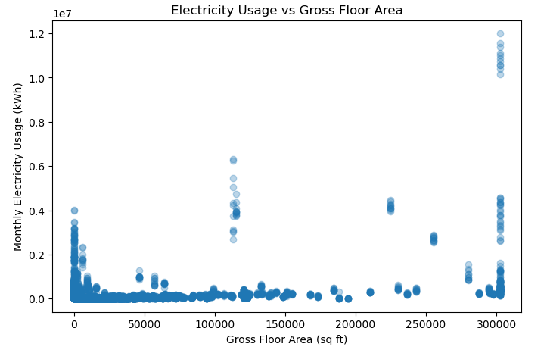
It is showing a positive upward trend.

Interpretation:
Larger buildings use more electricity overall, but variation is increased for large buildings, which suggests operational diversity.

5.4 Energy Consumption by type of property

A boxplot is used for comparing electricity consumption for building types.
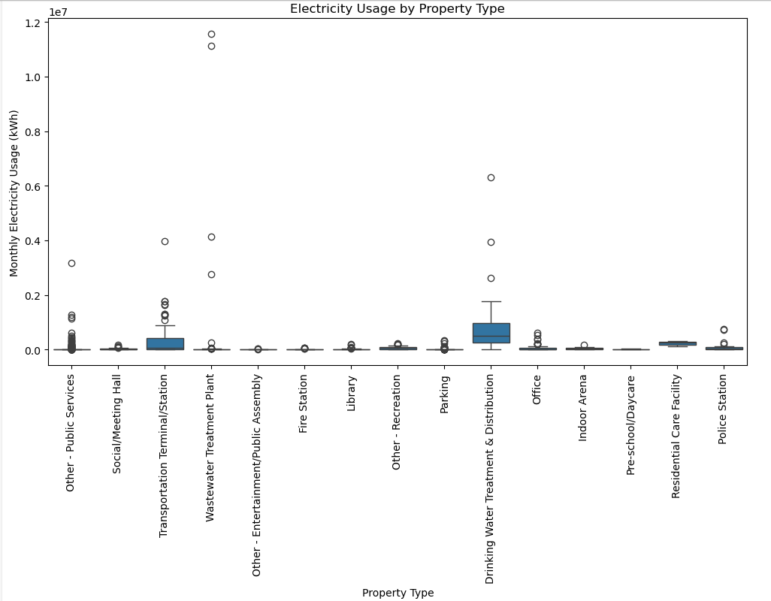

Interpretation:
Some building classes (industrial, large commercial) have larger central values of usage, whereas smaller retail or residential classes have smaller values.

5.5 Correlation Analysis
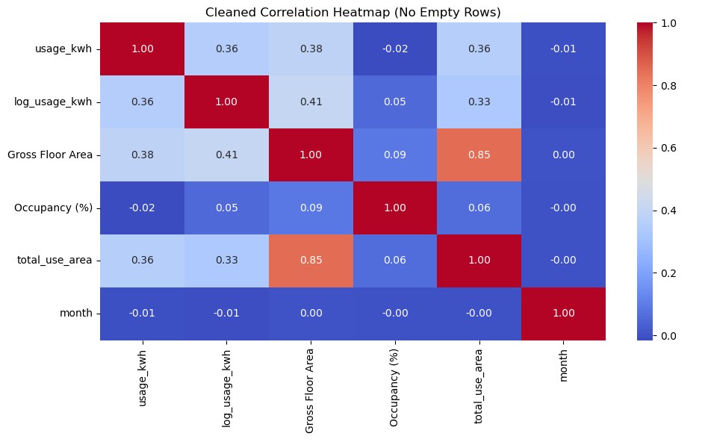
This heatmap shows the correlation between the key numeric variables including electricity usage, log-transformed electricity usage, gross floor area, occupancy, total use area, and month. The matrix is used to determine the correlation among consumption and building characteristics.
- Total Use Area and Gross Floor Area have a strong positive correlation (r = 0.85).
- There is moderate correlation between building size and the use of electricity.
- Month and occupancy (%) bear a slight positive correlation with the usage.
- Association and Skewness is maintained by the log transformation.

Feature Engineering:

- Following Feature were designed
- We designed the following features:

6.1 Temporal Features
- year
- month

6.2 Use Allocation Features
- nuses
- totalusearea

6.3 Encoded Categorical Variables

The column:
- Property Type - Self-Selected
was one-hot encoded to change it to numeric model friendly features.

6.4 Outlier and Log Transform
- Floor area is capped at 99th percentile
- logusage_kwh as target

Model Development
We have implemented 2 models:

7.1 Linear regression:
Characteristic:
- This is the easiest and fastest way to interpret
- Linear relationships are assumed though this model
- This model is used to compare more robust model

7.2 Random Forest Regressor
Characteristic:
- Its take care of nonlinear regression
- Interaction between the multiple features is captured
- Overfitting through ensemble learning is reduced
- This model works better than the baseline

7.3 Train and test split
- 80% training
- 20% testing
- Random state = 42 reproducibility

Model Evaluation:

In total 3 models were evaluated as follows:
- MAE( Mean Absolute Value)
- RMSE (Root Mean Square Error)
- R2 ( Coefficient of definition)

8.1 Linear Regression Results
- MAE: 1.6223
- RMSE: 2.2508
- R2: 0.3719

Interpretation:
The baseline Linear Regression model is used to explain about 37.2% of variance on log-transformed value of the monthly electricity usage. The error levels (MAE = 1.62 in log(kWh) units) show that a simple linear model has some difficulty describing the complexity and non-linearity in the data.

8.2 Random Forest Result:
- MAE: 0.8766
- RMSE: 1.6805
- R2: 0.6499

Interpretation:
The Random Forest model gives an MAE reduction of approximately 46 percent compared to the Linear Regression model, and the R2 increases from a value of approximately 0.37 to approximately 0.65. This translates to the fact that the Random Forest accounts for nearly 65% of the variance of the log-transformed electricity usage while it clearly outperforms the linear baseline. This confirms the fact that electricity consumption relies on the non-linear relationships and feature interactions that Random Forest can model better.

8.3 Actual V/s Predicted: Random Forest
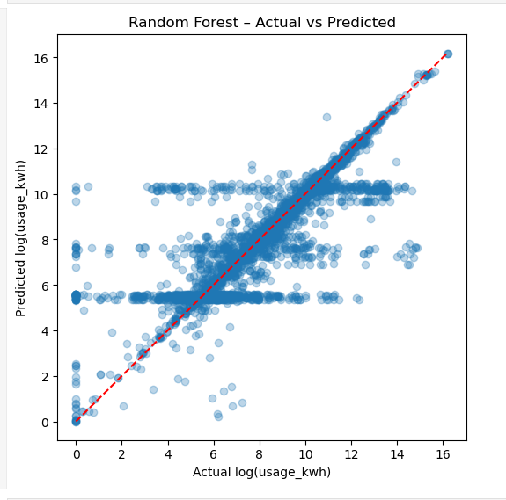

The scatter plot shows that most of the points are close to the line of 45 degrees, this indicates that the predictions of the Random Forest model closely match the actual log-transformed values of electricity usage. Deviations from the line are greater for a small number of extreme consumption readings, implying that the model is slightly too low or high for some extremely unusual buildings. All things considered, the visual alignment is consistent with the high performance seen in the evaluation metrics on numbers.

Interpretation and insight:

Key Insights

- Gross Floor Area is one of the most important drivers of consumption.

- Property Type has a significant influence on the consumption pattern.

- More diverse use type (higher n_uses) is correlated with diversity in energy behaviour.

- Random Forest is showing the electricity usage is not strictly linear.

Practical Implications

- Utility providers can get better at forecasting.
- Efficient programs that are having high priorities for integrating into the buildings can be identified by the policymakers.
- Building managers can make more realistic benchmark comparisons of energy performance.

Limitations
- Lack of weather information which is important for identifying patterns for consumption of electricity
- Incomplete entries in some of the buildings
- Monthly readings have a varying number of billing days.

Conclusion:

This project successfully:
- Cleaned and combined four complicated real-world datasets
- Performing meaningful exploratory data analysis
- Engineered features to improve the quality of the prediction
- Developed and compared machine learning models
- Identified key drivers to electricity consumption

Random Forest model achieved the best results and positive results that electricity consumption could be explained as a result of nonlinear interactions of building characteristics. The Random Forest Regressor is significantly superior to the baseline and has a great performance as well, which also reflects the significance of nonlinear relations among features. The modeling methodology is a solid foundation towards improved energy predictions and sustainability initiatives decision making. The analysis provides a solid structure of how to power the future and make sustainable decisions.

